We will implement NEAT (neural evolution of augmenting topologies), to simulate evolution and mutation cycle of 2D self-driving cars.

We will draw some random tracks in the GIMP software, then we will set our starting and ending positions. These tracks will be used to simulate our 2D AI cars. The tracks initially will be pretty basic, as we advance with our training process, the tracks will start to get more complex and crazier.

Our car model will have 5 input neurons, i.e. sensors and 4 output neurons ,i.e. actuators viz go left, go right, increase speed and decrease speed.

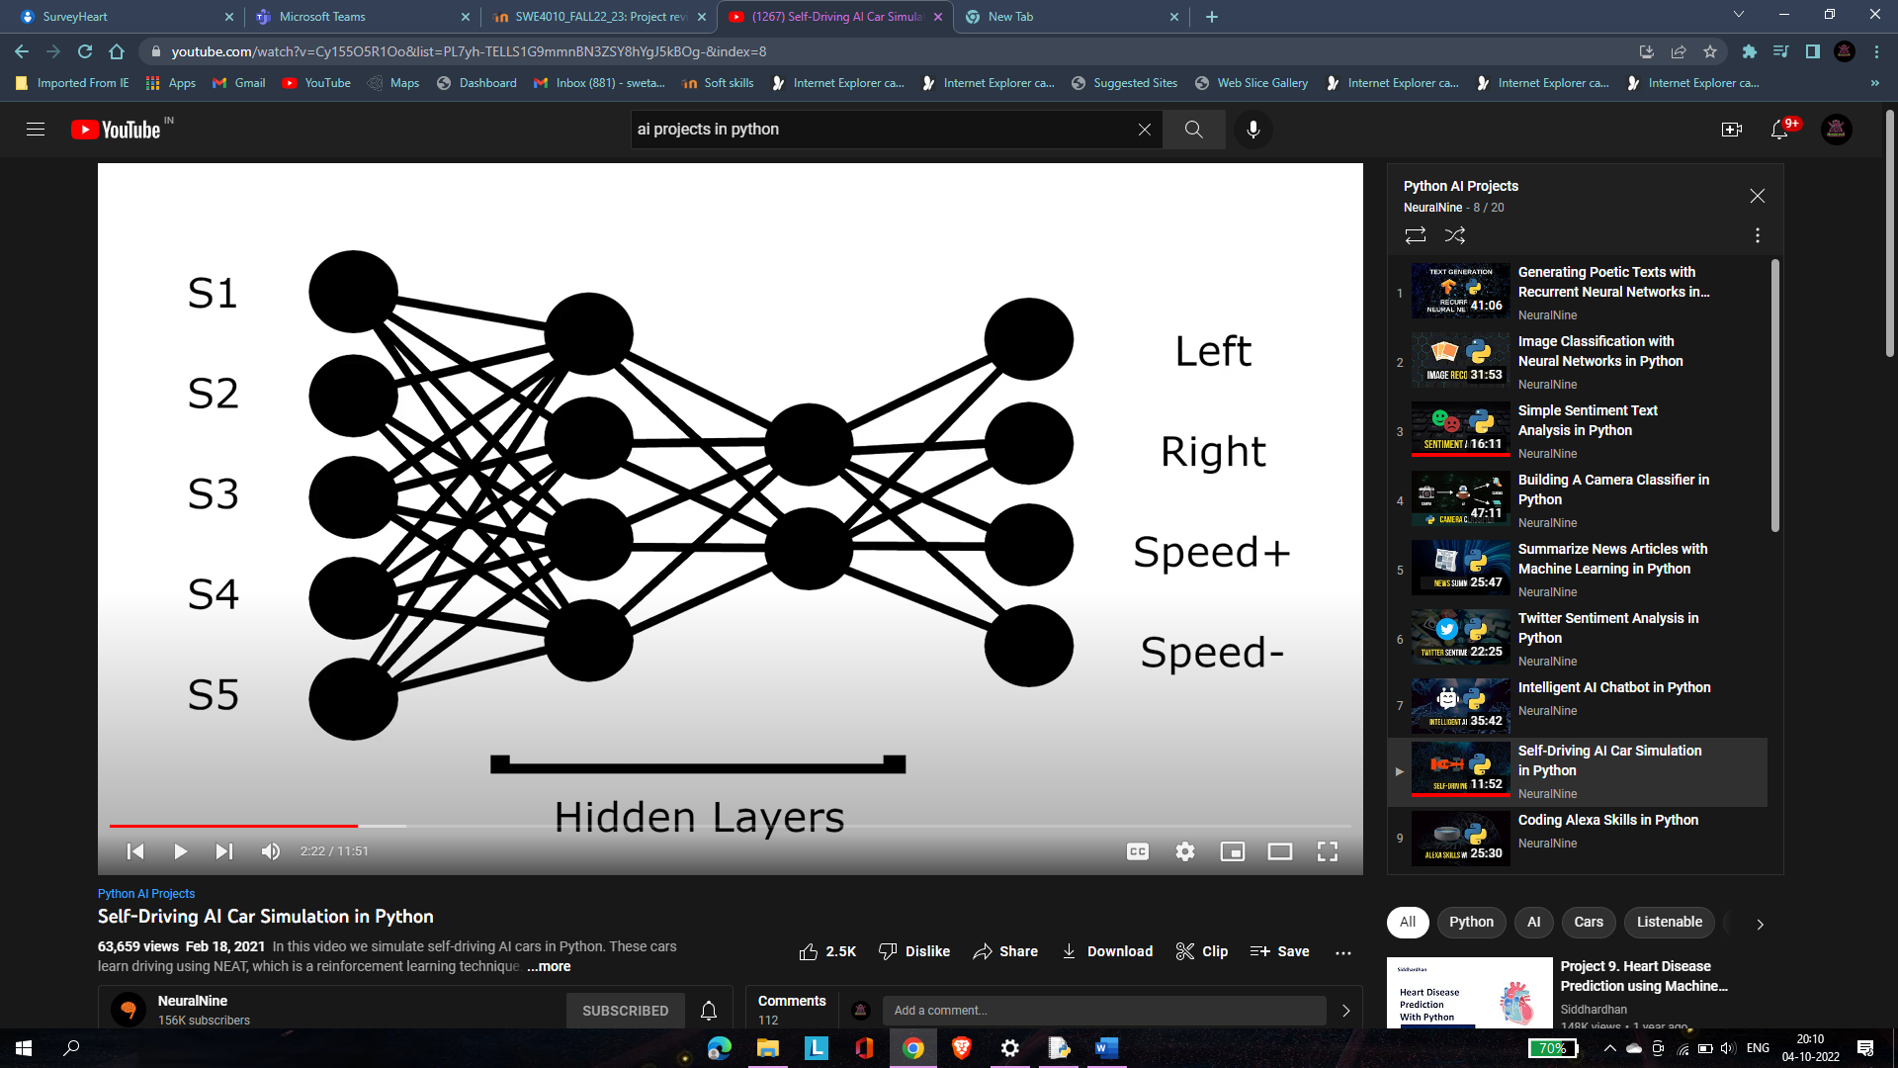

The cars will be assigned with a fitness metric system. The longest travelling car will emerge as dominant and will reproduce further.

Now, there’s a catch….after a few generations, say 5; some cars may be able to conquer the track properly, however, not all will be needed by us. Say, a car is conquering the track with 60 speed, another with 50 speed and 2 more with 30 and 26 speed respectively, then, the one with 60 speed is our point of interest, the rest can be discarded and we can focus on the most dominant one to improve its accuracy and efficiency.

This is our working model.

Config file: https://neat-python.readthedocs.io/en/latest/config_file.html